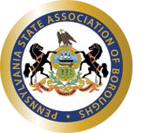

OFFICIAL AND APPROVED MINUTES

BERLIN BOROUGH COUNCIL SPECIAL MEETING

November 19, 2015 - 11:00 a.m.

- The President calls the meeting to order.
- Pledge of Allegiance to the American Flag.
- President Kerrie Broderick offers a non-denominational prayer.

ROLL CALL
Barb Zerfoss Thomas Fisher Roger Clarke John Harding, Jr. Eric Glotfelty
Mayor Joseph Krause (Absent) Brett Custer
Kerrie Broderick / President

Also in attendance were:
Terry Metzgar, Borough Executive Secretary

Members of the public: See Attached Roster

Citizen Comments:

President’s Report

Discussion on eliminating the borough property tax: Our 1.5 mill property tax yields $39,155 per year.

In response to difficult economic conditions that, for all practical purposes, collapsed our local economy, the Berlin Borough Council has elected to eliminate all property taxes.

With the coal industries collapse Berlin residents face depression era levels of unemployment.

When our people are hurting, local government needs to respond in a manner that eases the burden for its citizenry.

That's why Berlin Borough Council is taking the unprecedented step of eliminating property taxes.

It is worth noting that by eliminating the property tax we are NOT substituting one tax for another. We are simply abolishing the property tax and then reducing our budget accordingly.

Local government should encourage people to improve their property not penalize them for their efforts as does the regressive property tax scheme.

While abolishing property taxes may seem unorthodox to some, it is an indication of what can be done when a borough council works for the genuine benefit of the folks that they serve.

The Berlin Borough proposed and revised 2016 budget is attached for your review. This budget eliminates the property tax in Berlin Borough by reducing the millage from 1.5 mills to Zero.

Motion by Brett Custer and seconded by Tom Fisher rescinding the motion of the November 5, 2015 meeting which proposed a tax rate of 1.5 mills.
Aye: 5
Nay: 2
Roll Call Vote:
No: Barb Zerfoss Yes: Thomas Fisher No: Roger Clarke Yes: John Harding, Jr. Yes: Eric Glotfelty Yes: Brett Custer Yes: Kerrie Broderick

Motion Passed

Motion by Roger Clarke and seconded by John Harding acknowledging receipt of, and tentatively approving the revised 2016 budget for the Borough of Berlin, with final action on the budget scheduled to be taken at the December 3, 2015, Borough Council Meeting.
Aye: 7
Nay: 0
Motion Passed

Motion by Eric Glotfelty and seconded by Tom Fisher directing the legal advertising of proposed Berlin Borough Ordinance No. 338 relative to establishing the real property tax rate for 2016 at Zero Mills.
Aye: 5
Nay: 2
Roll Call Vote:
No: Barb Zerfoss Yes: Thomas Fisher No: Roger Clarke Yes: John Harding, Jr. Yes: Eric Glotfelty Yes: Brett Custer Yes: Kerrie Broderick Motion Passed

Motion by Roger Clark and seconded by Barb Zerfoss awarding a $150 bonus to each borough worker for their exemplary efforts in restoring water service during the consecutive series of water line breaks on 101615 and 101715. This payment is generously sourced from the Berlin Municipal Authority with the Borough Council’s concurrence.
Ayes: 7
Nays: 0 Motion Passed

Motion by Barb Zerfoss and seconded by Brett Custer awarding a $50 end-of-year bonus to each part- time borough worker.
Ayes: 7
Nays: 0 Motion Passed

Committee Reports:

Electric & Equipment
Brett Custer (Chair)

Motion by Eric Glotfelty and seconded by Brett Custer authorizing the borough secretary to purchase replacement electric meters at a cost not to exceed $5000.
Ayes: 7
Nays: 0 Motion Passed

Internal Generation Update:
We are awaiting the RFP to come back from our Special Counsel, at which point we will solicit sealed bids. This may happen as early as next week.

At 11:42 AM the council adjourned to executive session to review and discuss agency business which, if conducted in public, would violate a lawful privilege or lead to the disclosure of information or confidentiality protected by law, including matters related to the initiation and conduct of investigations of possible or certain violations of the law and quasi-judicial deliberations.

Motion by Eric Glotfelty and seconded by John Harding to adjourn to executive session. Aye: 7
Nay: 0
Motion Passed

Motion by Brett Custer and seconded by Eric Glotfelty to reconvene the regular meeting at 12:14 PM.
Aye: 7
Nay: 0
Motion Passed

At 12:14 PM, the council reconvened the regular meeting.

Motion by Brett Custer and seconded by John Harding authorizing a thermo-graphic analysis of the borough’s electric distribution system.
Ayes: 7
Nays: 0 Motion Passed

Motion by Roger Clarke and seconded by Brett Custer to remove the unnecessary license plate from the borough backhoe.
Ayes: 7
Nays: 0 Motion Passed

The Council directed the borough secretary to enlist Craig Leydig’s help in in clearing / brush- hogging the newly acquired Fieg Property Generator Site.

Motion by Eric Glotfelty and seconded by Barb Zerfoss to adjourn this Special Meeting of the Berlin Borough Council at 12:17 PM.
Aye: 7
Nay: 0
Motion Passed

Note: The next regular meeting of the Berlin Borough Council is scheduled for December 3, 2015, beginning at 7:00 p.m., at the Berlin Borough Council conference/meeting room, 700 North Street, Berlin, Pennsylvania.

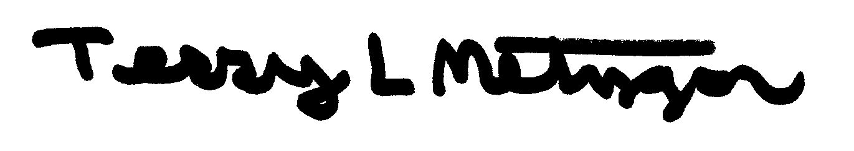
Terry L. Metzgar
Executive Borough Secretary November 19, 2015

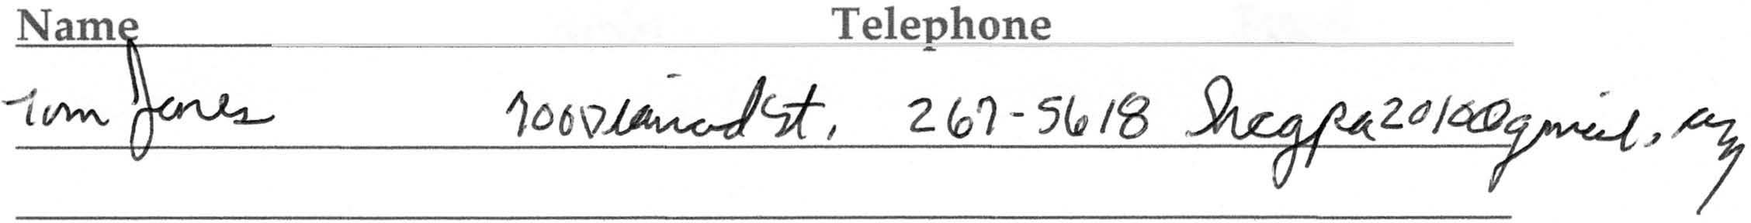Guest Registry

Special Berlin Borough Council Meeting November 19, 2015
Please print

Address Email

If you would like to address the Council, please enter your name and the subject that you wish to discuss here:

Thank You for attending the Berlin Borough Council Meeting. Your input is both welcomed and appreciated.

